Index and Contact Us pages:

Debugging errors on the pages. This this index page:

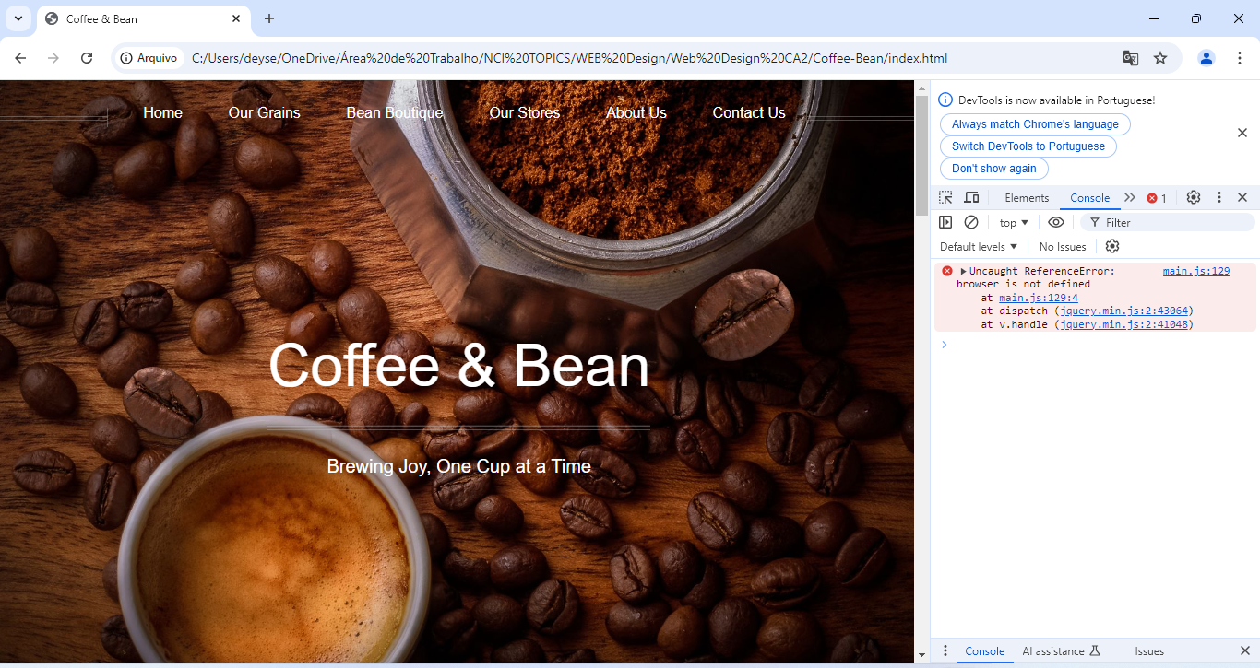

Identifying the error, showed on line 129:

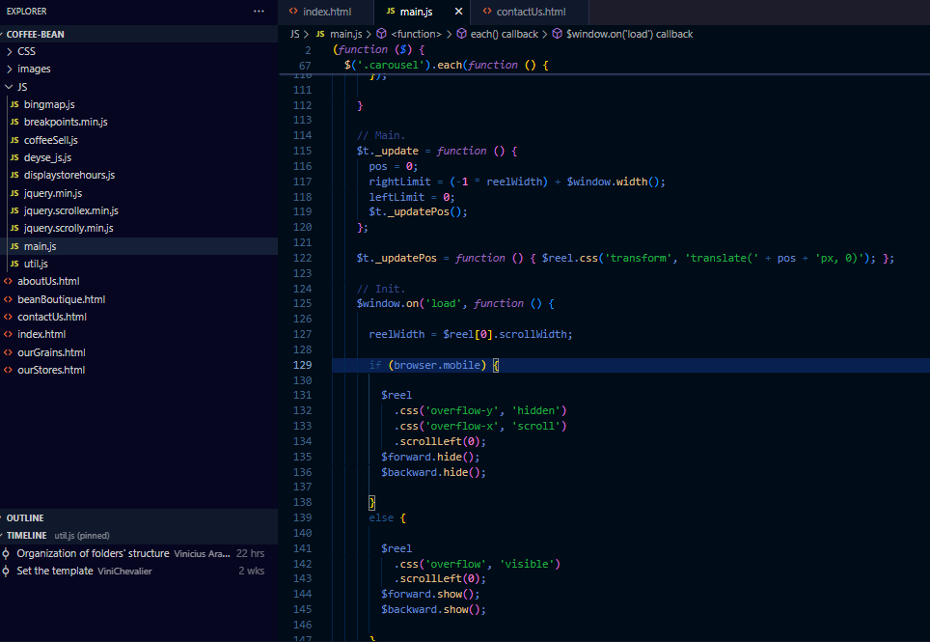

Problem solved changing the conditional:  
  
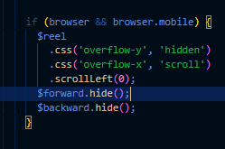  
Testing website functionality:

Opening correctly on Google Chrome browser:

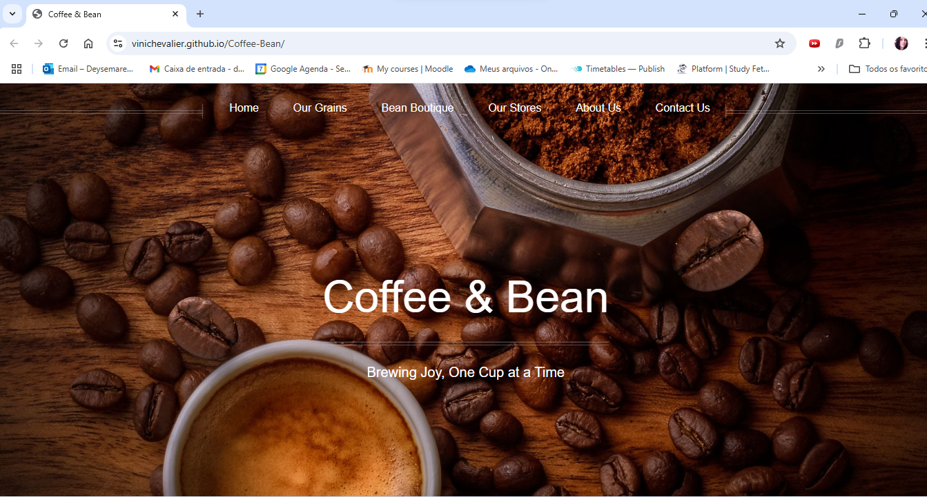

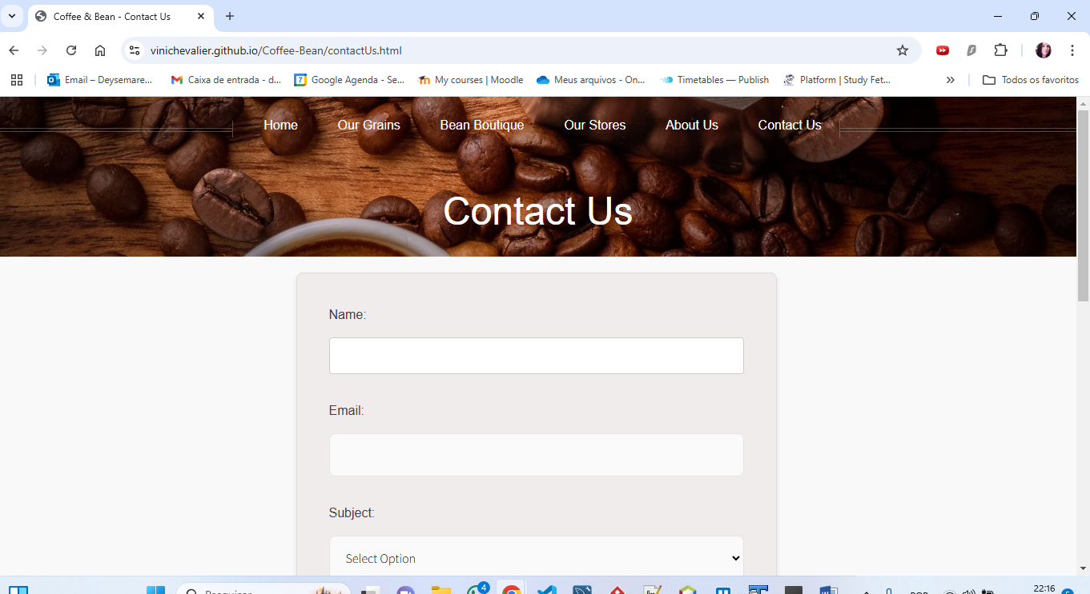

Opening correctly on Microsoft Edge browser:

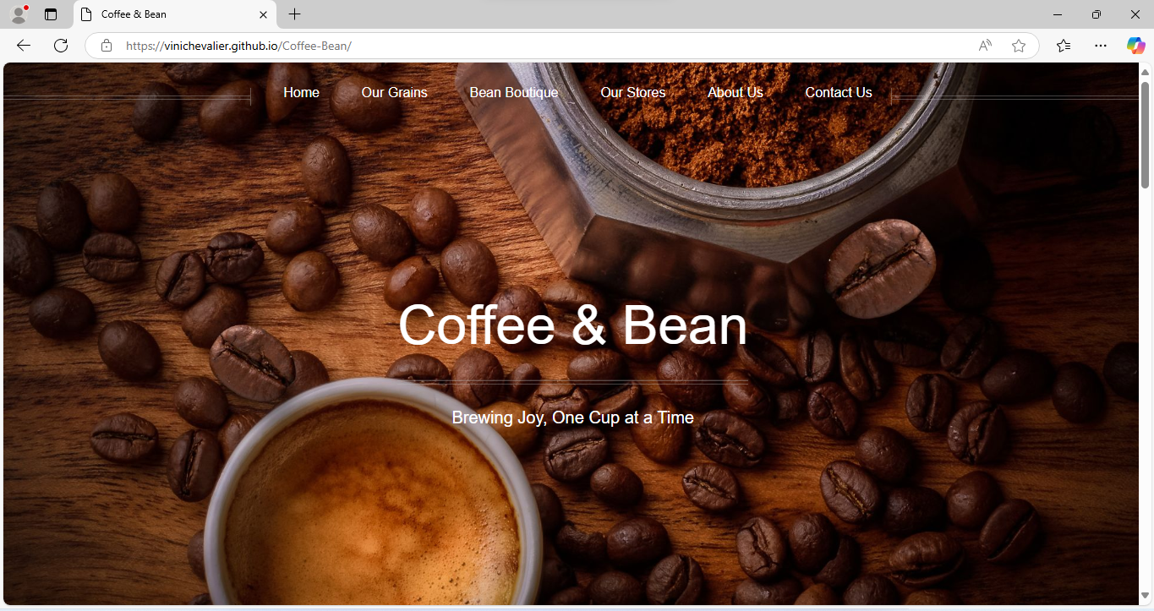

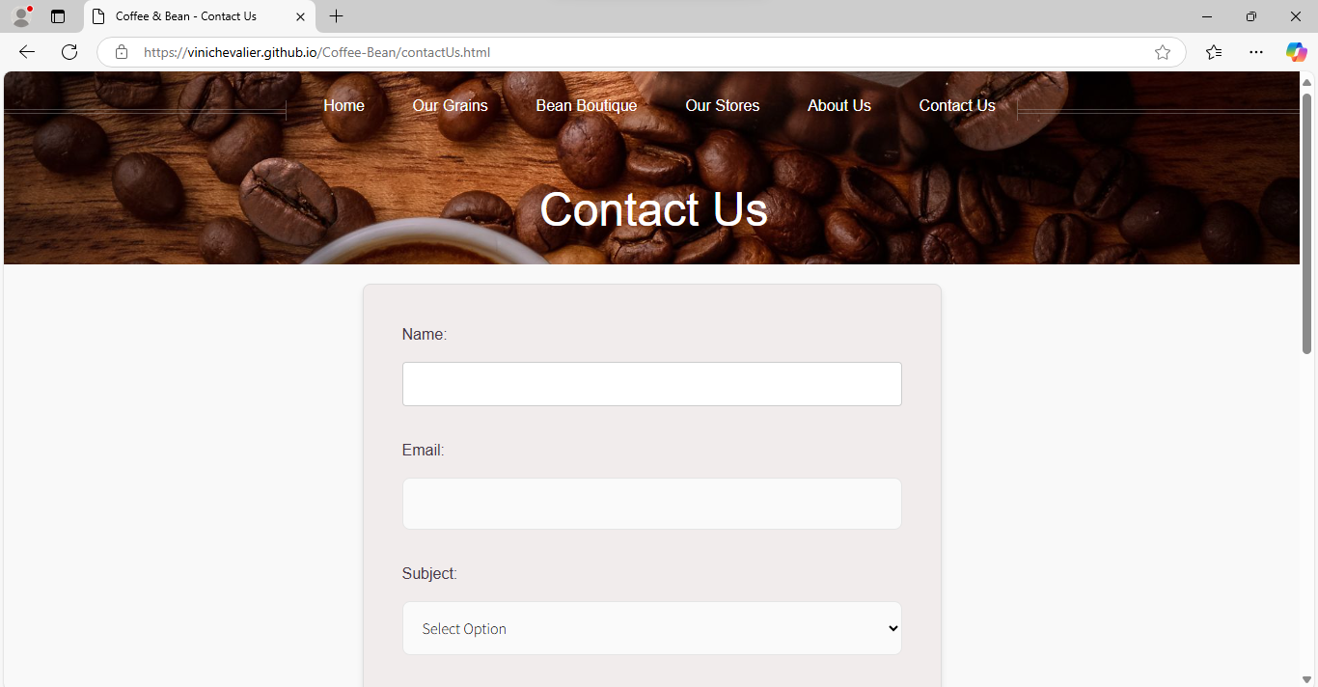

Carousel functionality, working well, where some differences can be seen, such as the Microsoft Edge scroll bar is thinner and rounded compared to that of Google Chrome  
  
Google Chrome carousel:  
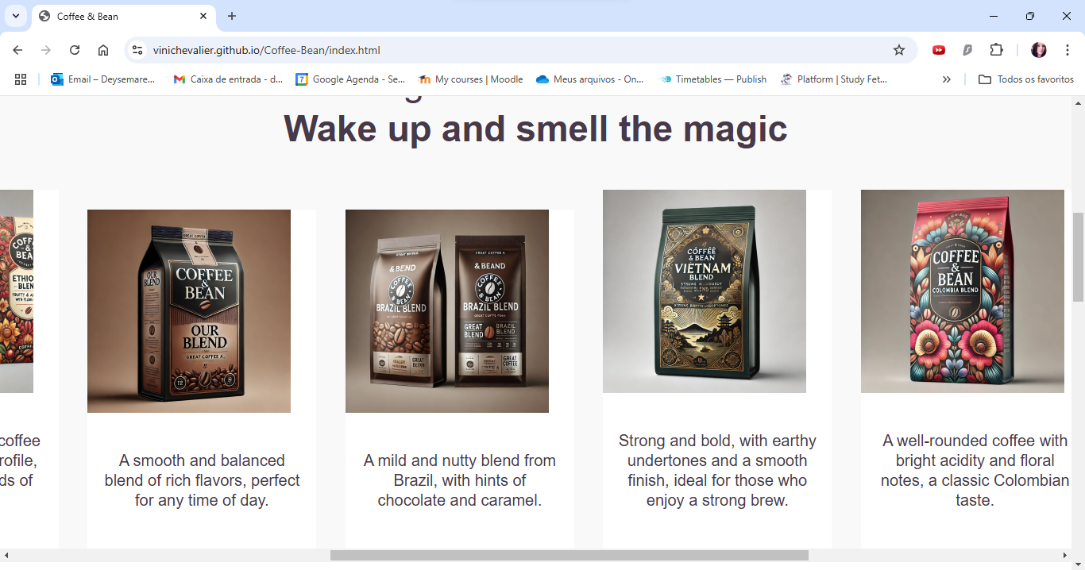

Microsoft Edge carousel:

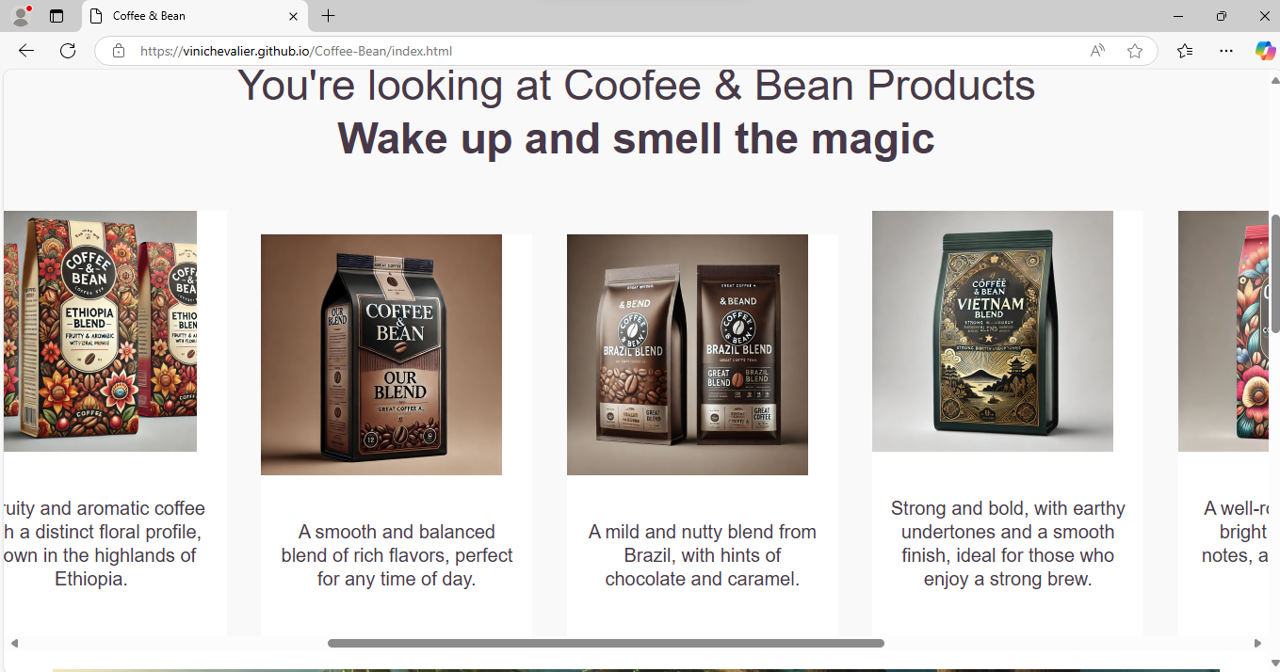  
  
Responsiveness on pages and mobile:  
  
Microsoft Edge:  
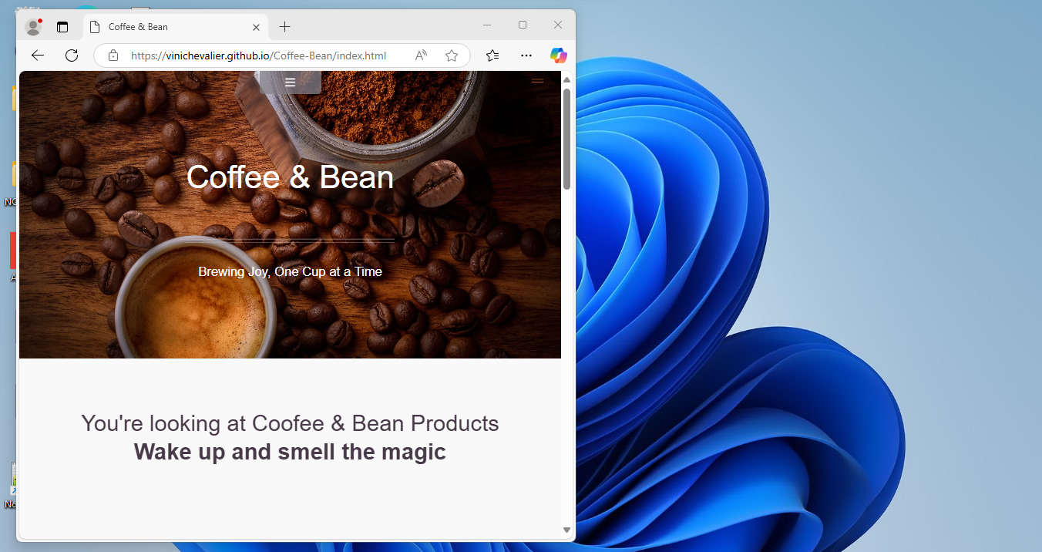

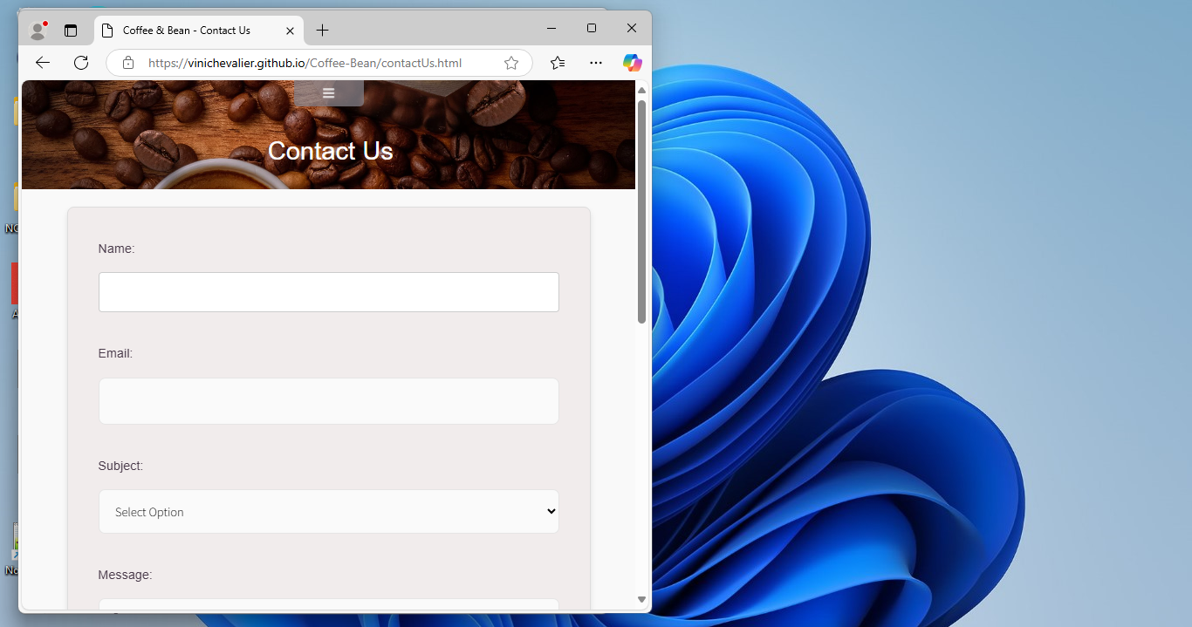  
  
Google Chrome:  
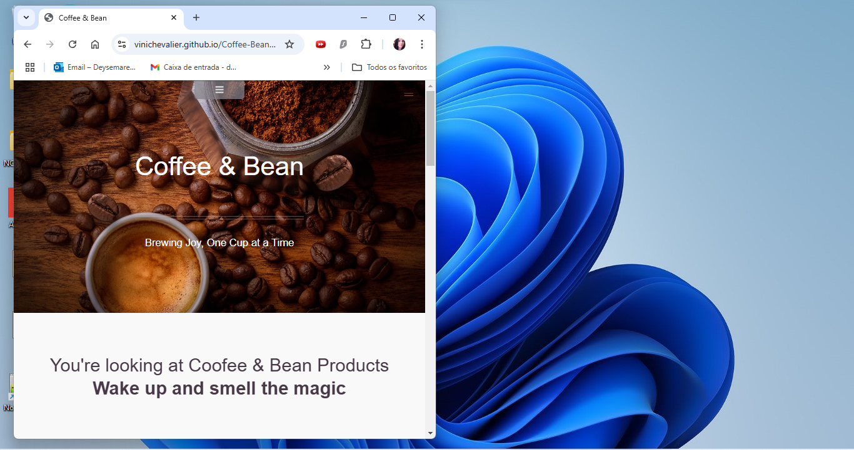

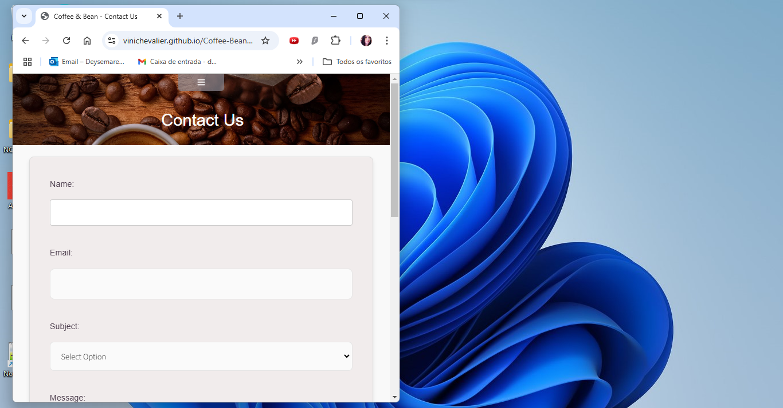

On mobile:

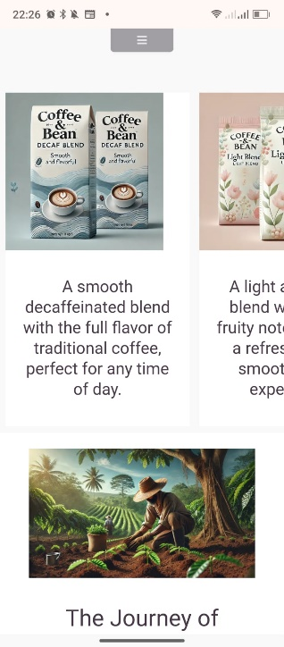

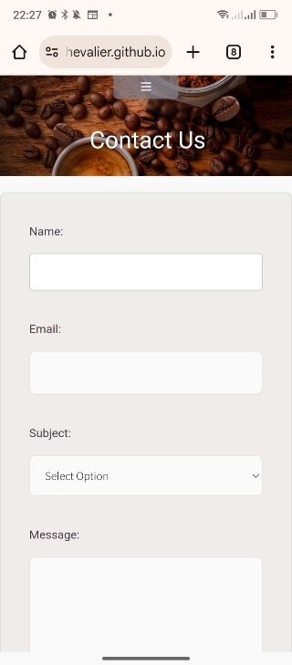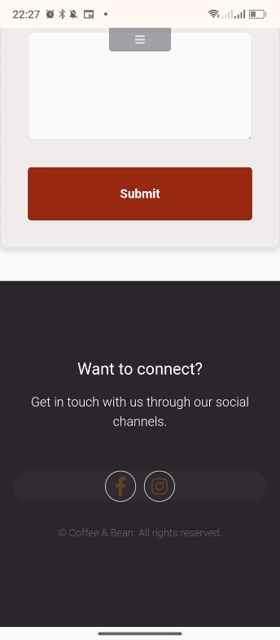

CSS validation for Index page:  
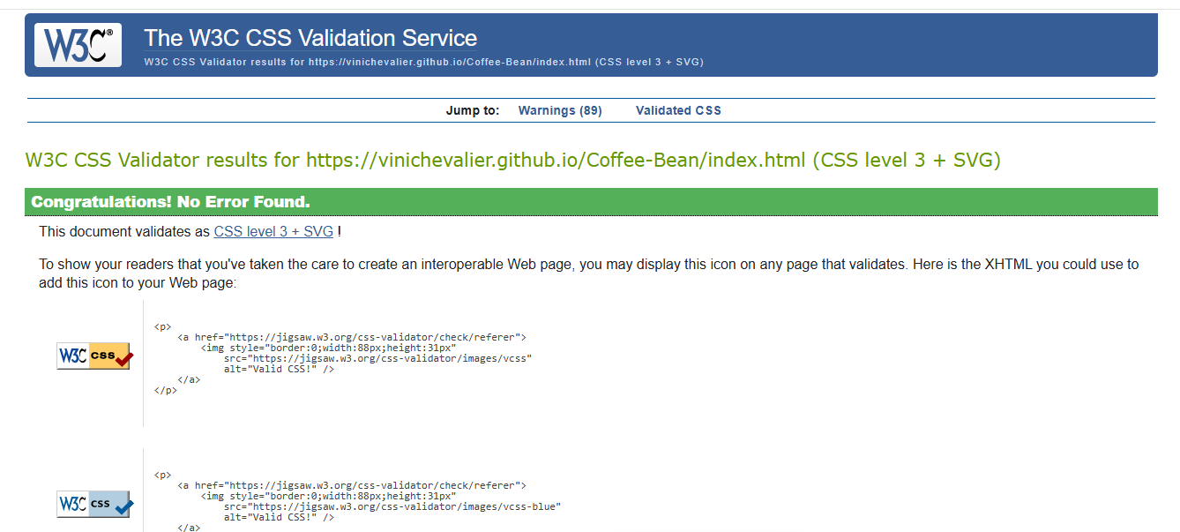

CSS validation for ContacUs page:

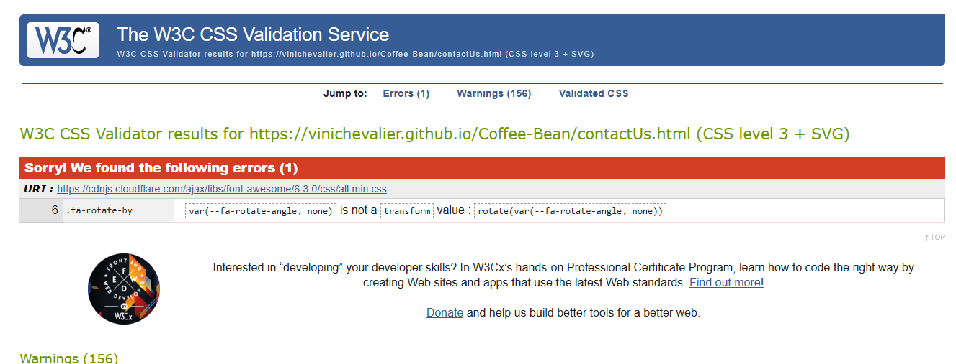

Speed validation for Index page on PageSpeed:  
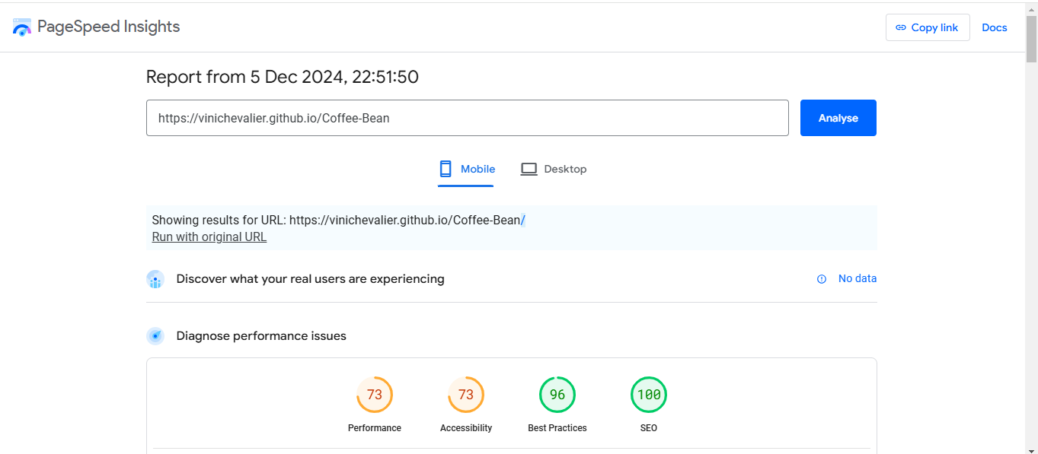

Speed validation for contactUs page on PageSpeed:

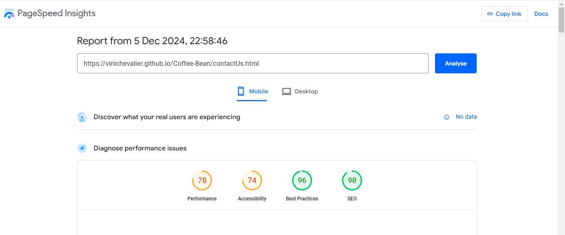

Speed validation for Index page on Pingdom:

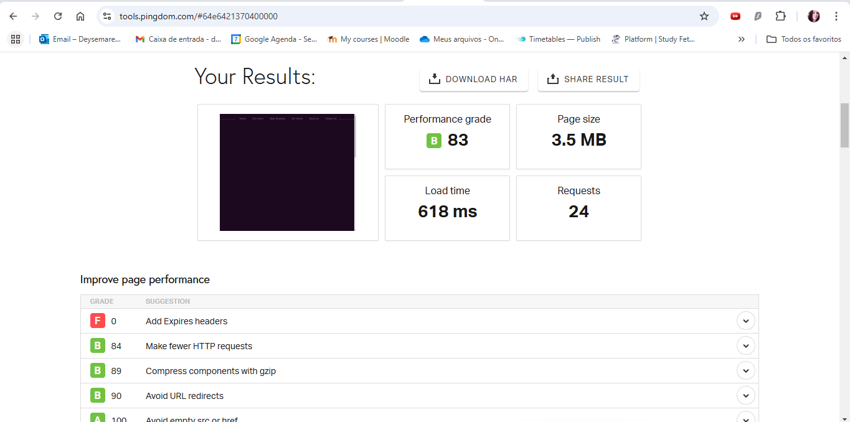

Speed validation for Contact Us page on Pingdom:

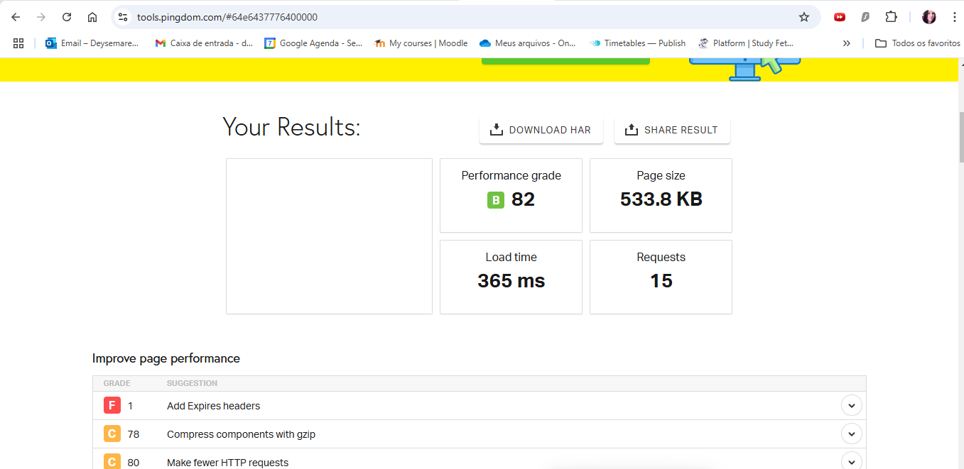

Index page validation on validator.23:

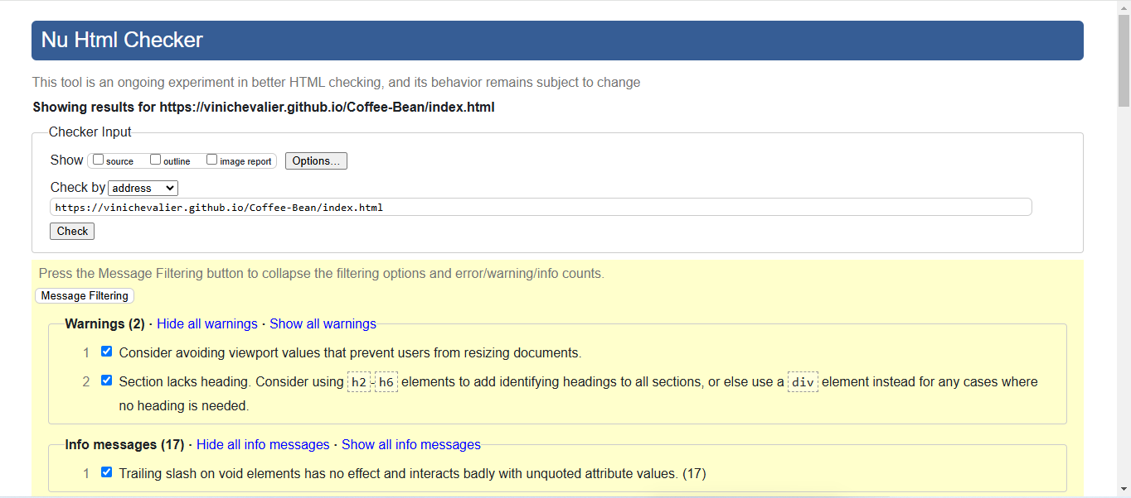

ContactUs page validation on validator.23

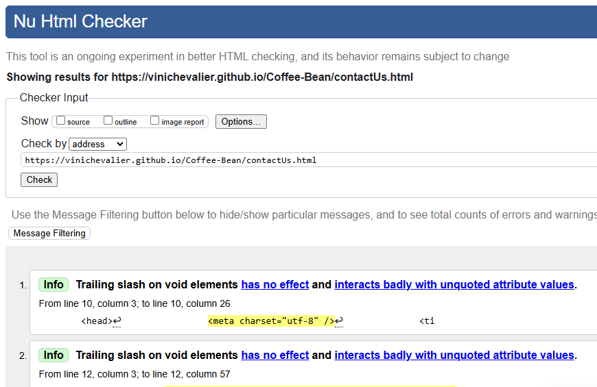

The purpose of this JavaScript code is to validate an email address entered by the user in a form and provide feedback based on the validity of the email.

When the user submits the form, the validateForm() function is triggered.

validateEmail() checks if the input is a valid email.They are going to displays "Please enter a valid email address." if the input is invalid or displays "Email is valid." if the input is valid. 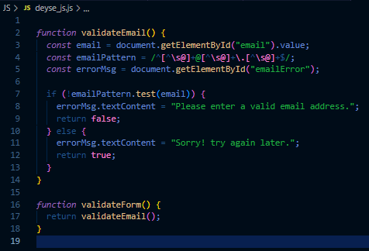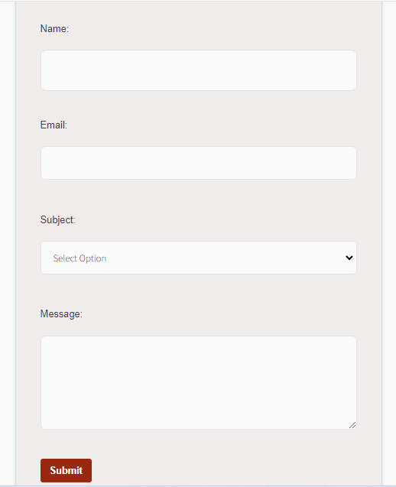If invalid, the form is not submitted (return false). If valid, the form submits (return true).